DOCUMENT: TECHNOLOGY STACK

Phase | Project Design Phase II
Document | Technology Stack (Architecture & Stack)
Project Name | PetPaws – Pet Foods & Accessories Store
Team ID | [TEAM-ID]
Date | 14 June 2026
Maximum Marks | 4 Marks

Technology Stack (Architecture & Stack)

Technical Architecture Overview
PetPaws follows a 3-tier MERN stack architecture: Presentation Layer (React.js SPA), Application Layer (Node.js + Express.js REST API), and Data Layer (MongoDB + Mongoose ODM).

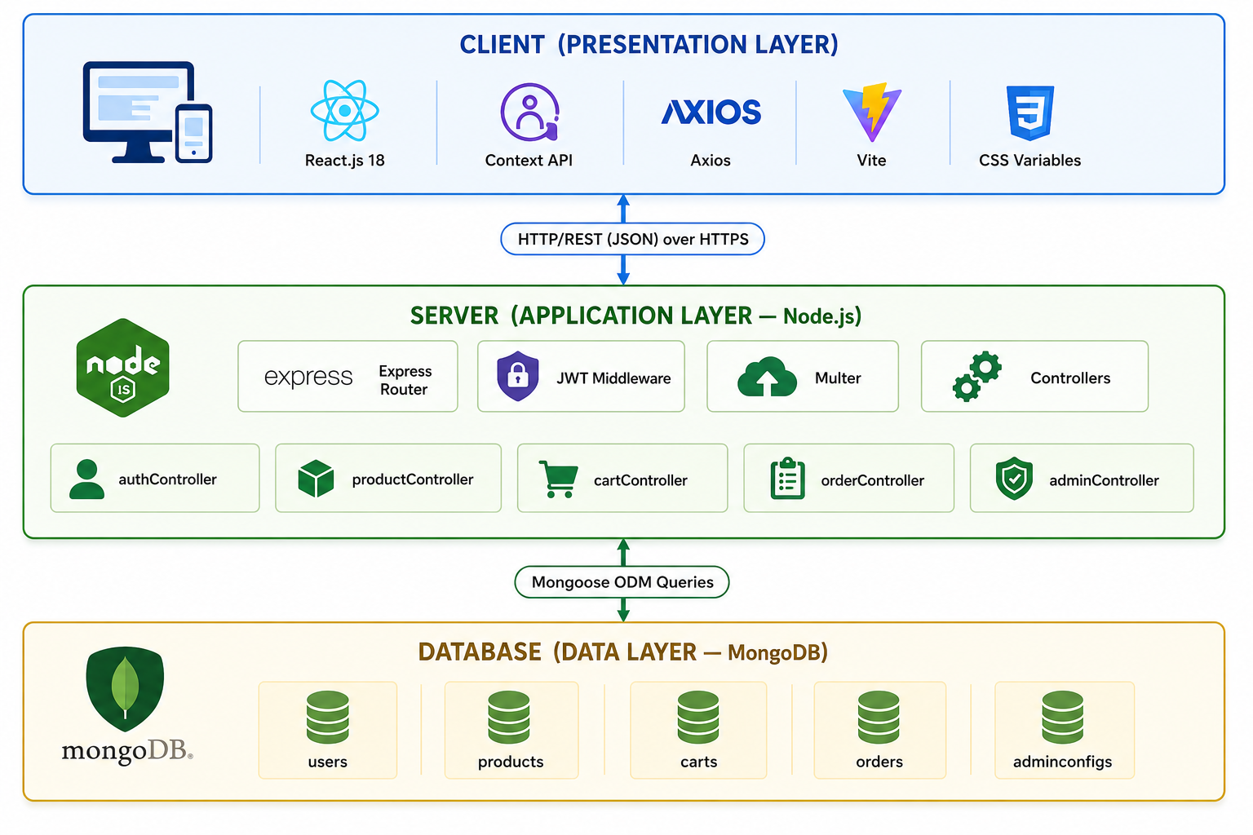

Table 1: Components & Technologies
S.No | Component | Description | Technology
1 | User Interface | Single Page Application (SPA) served via browser on desktop and mobile | React.js 18 (Vite 5 build tool)
2 | Client-Side Routing | Declarative navigation with protected routes for authenticated and admin-only pages | React Router v6
3 | Global State Management | AuthContext for JWT user state; CartContext for real-time cart count and totals | React Context API + localStorage
4 | HTTP Client | Centralised Axios instance with JWT request interceptor and 401 response interceptor | Axios 1.x
5 | Styling | CSS Custom Properties (design tokens), responsive grid, mobile-first breakpoints | Pure CSS3 with CSS Variables
6 | Notifications | Non-blocking toast alerts for cart actions, authentication, and order events | react-hot-toast 2.x
7 | Icons | Lightweight SVG icon set used across Navbar, cart, profile, and admin UI | react-icons (Feather set)
8 | API Server / Application Logic | RESTful API handling all business logic: auth, products, cart, orders, reviews, wishlist, admin | Node.js (v18+) + Express.js 4
9 | Authentication Logic | JWT generation, verification middleware (protect), role authorization middleware (adminOnly) | jsonwebtoken + bcryptjs
10 | Database | Document-oriented NoSQL database for Users, Products, Orders, Cart, Reviews, AdminSettings collections | MongoDB 7.x (local) / MongoDB Atlas (cloud)
11 | Database ODM | Schema definition, validation, pre-save hooks (password hashing, discount computation), text indexes, aggregation pipeline | Mongoose ODM v8
12 | Environment Configuration | Stores PORT, MONGO_URI, JWT_SECRET, JWT_EXPIRE; promotes from dev to prod without code changes | dotenv 16.x
13 | Development Server & Proxy | Fast HMR in development; proxies /api/* to localhost:8000 to eliminate CORS issues in dev | Vite 5 dev server
14 | Version Control | Source code management, branching strategy, and collaborative development | Git + GitHub
15 | API Testing | Manual API endpoint testing and documentation during development | Postman
16 | Code Editor | Primary development IDE with integrated Git, terminal, and extension ecosystem | Visual Studio Code

Table 2: Application Characteristics
S.No | Characteristic | Description | Technology
1 | Open-Source Frameworks | All technologies used in PetPaws are open-source with active community support: React (Meta), Express.js (Node.js Foundation), MongoDB (SSPL / Apache 2.0), Mongoose (MIT), Vite (MIT), Axios (MIT) | React 18, Express 4, MongoDB, Mongoose 8, Vite 5, Axios
2 | Security Implementations | Password storage: bcrypt SHA-256 hashing with 10 salt rounds. Token security: JWT HS256 algorithm with 7-day expiry. API protection: JWT middleware on all private routes. Role enforcement: adminOnly middleware for admin routes. Input validation: Mongoose schema validators. Soft delete: isActive flag prevents data loss. | bcryptjs, jsonwebtoken, Mongoose validators, CORS
3 | Scalable Architecture | Three-tier architecture (Presentation → API → Database) enables independent horizontal scaling of each layer. RESTful stateless API supports load balancing without shared session state. MongoDB Atlas auto-sharding supports petabyte-scale growth. Modular Express route/controller structure enables microservice decomposition. | 3-tier MERN, MongoDB Atlas sharding, stateless JWT
4 | Availability | Decoupled deployment: frontend (Vercel CDN), backend (Railway/Render auto-restart), database (MongoDB Atlas 99.995% uptime with replica set failover). Stateless JWT authentication eliminates single-point-of-failure session stores. Vite proxy in development; environment-driven base URL in production for zero-downtime migrations. | Vercel, Railway/Render, MongoDB Atlas Replica Set
5 | Performance | API pagination: 12 products/page, 20 orders/page reduces response size. MongoDB text index on (name, description, brand, tags) enables fast full-text search. Server-side aggregation pipeline for dashboard KPIs avoids large client-side data processing. Vite production build with code splitting and tree-shaking minimises JavaScript bundle size. React state management avoids unnecessary re-renders via Context isolation. | MongoDB text index, aggregation pipeline, Vite code splitting

